**Functions**

**Scenario 1:**

CREATE OR REPLACE FUNCTION CalculateAge(

  dob IN DATE

) RETURN NUMBER IS

  age NUMBER;

BEGIN

  age := FLOOR(MONTHS_BETWEEN(SYSDATE, dob) / 12);

  RETURN age;

END;

/

SELECT Name, CalculateAge(DOB) AS Age

FROM Customers;

**Output:**

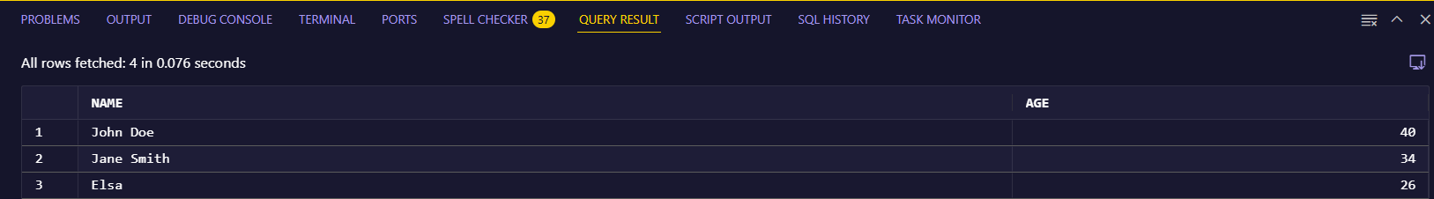

**Scenario 2:**

CREATE OR REPLACE FUNCTION CalculateMonthlyInstallment(

  loan_amt IN NUMBER,

  int_rate IN NUMBER,

  yrs      IN NUMBER

) RETURN NUMBER IS

  emi NUMBER;

BEGIN

  emi := (loan_amt * int_rate / 1200) /

         (1 - POWER(1 + int_rate / 1200, -12 * yrs));

  RETURN emi;

END;

/

SELECT CalculateMonthlyInstallment(5000, 5, 5) AS EMI FROM dual;

**Output:**

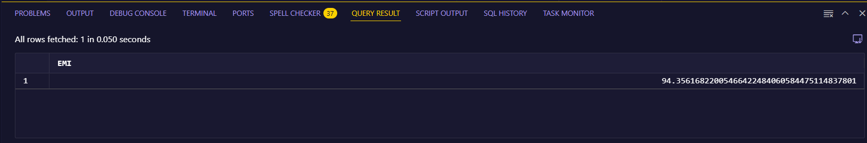

**Scenario 3:**

CREATE OR REPLACE FUNCTION HasSufficientBalance(

  acc_id IN NUMBER,

  amt    IN NUMBER

) RETURN CHAR IS

  bal NUMBER;

BEGIN

  SELECT Balance INTO bal

  FROM Accounts

  WHERE AccountID = acc_id;

  IF bal >= amt THEN

    RETURN 'TRUE';

  ELSE

    RETURN 'FALSE';

  END IF;

EXCEPTION

  WHEN NO_DATA_FOUND THEN

    RETURN 'FALSE';

END;

/

SELECT AccountID, HasSufficientBalance(AccountID, 800) AS Status

FROM Accounts;

**Output:**

